Nama : Andri Firman Saputra  
NIM : 201011402125  
Kelas : 05TPLP016  
Tugas : Basis Data II – Latihan 9

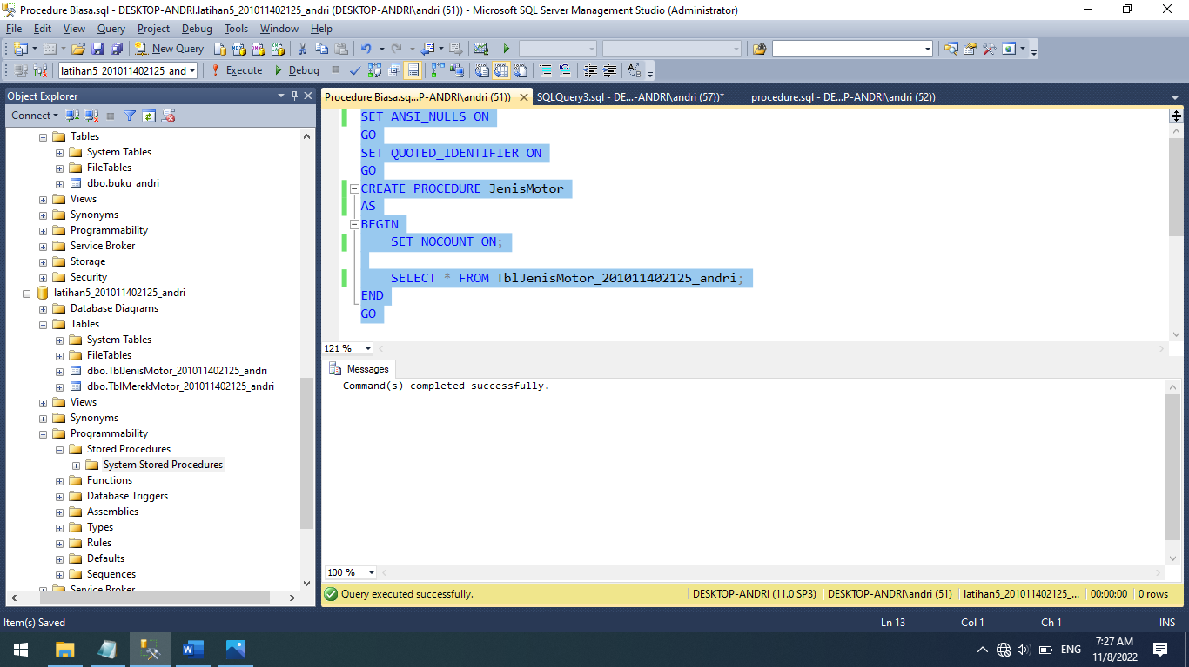

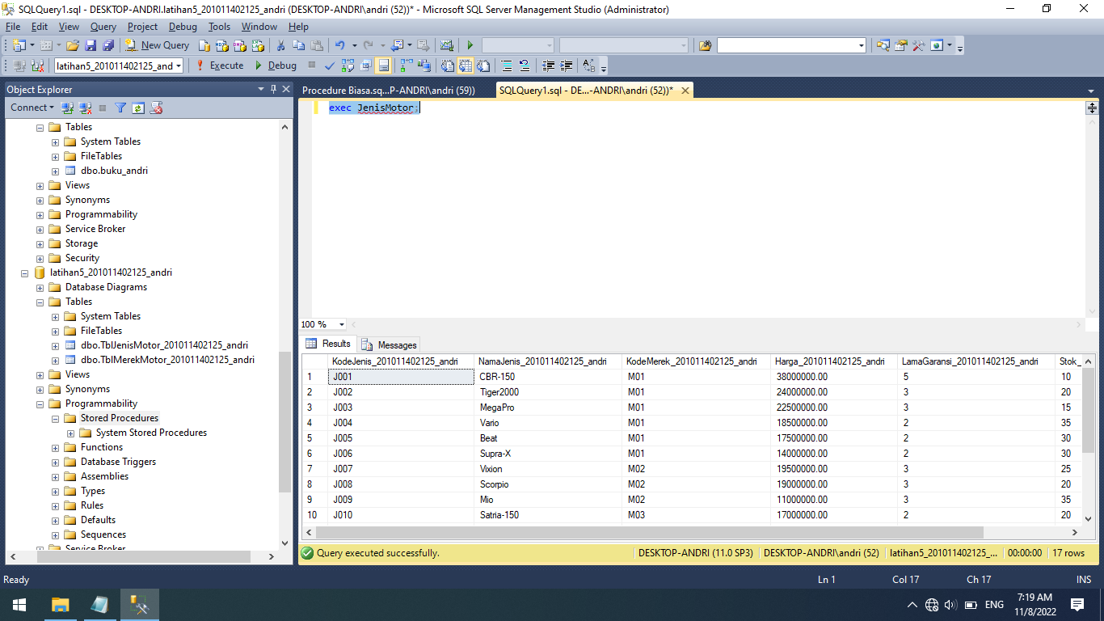

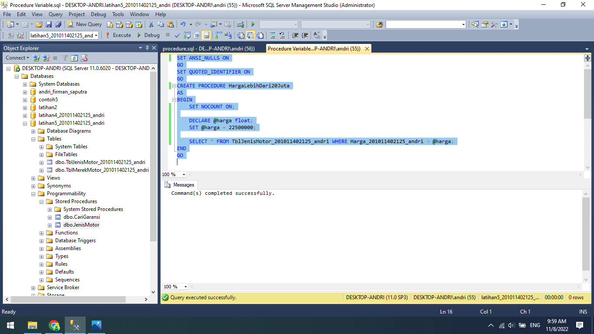

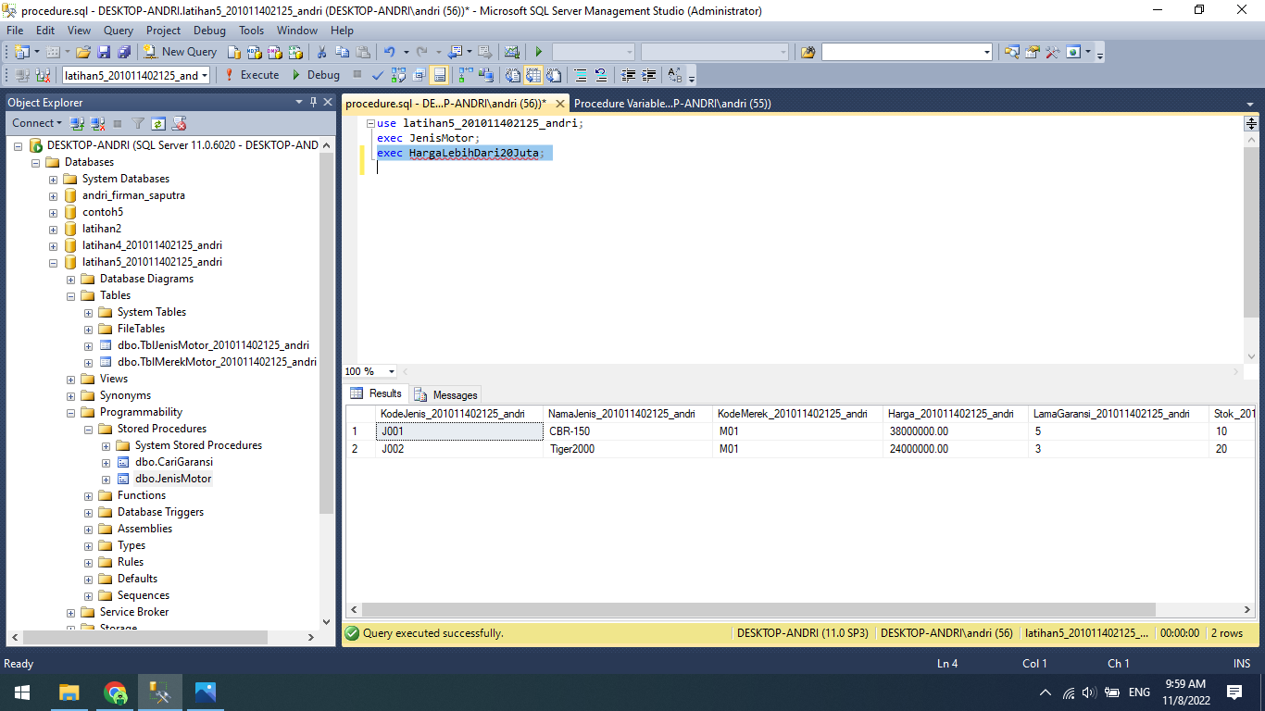

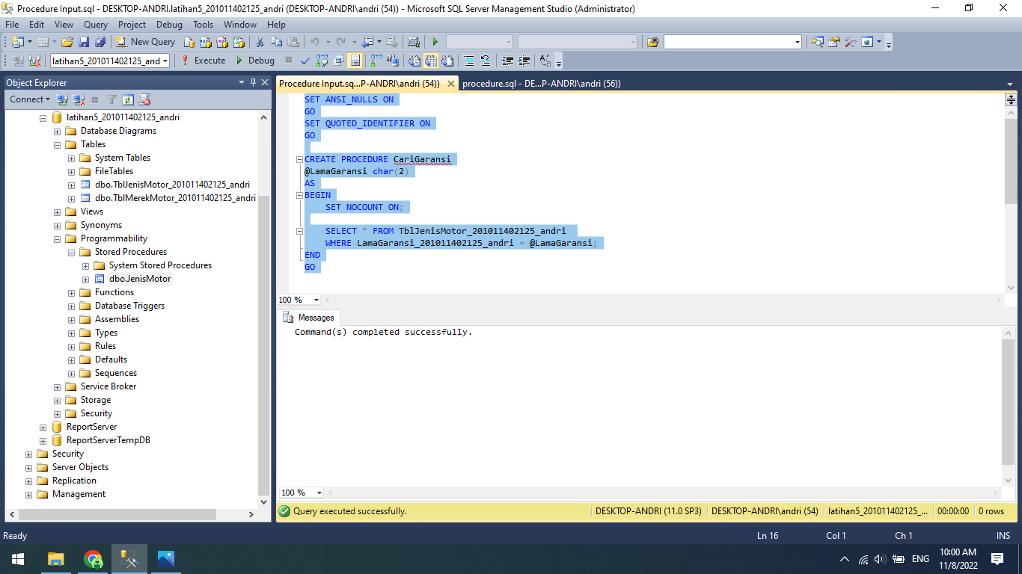

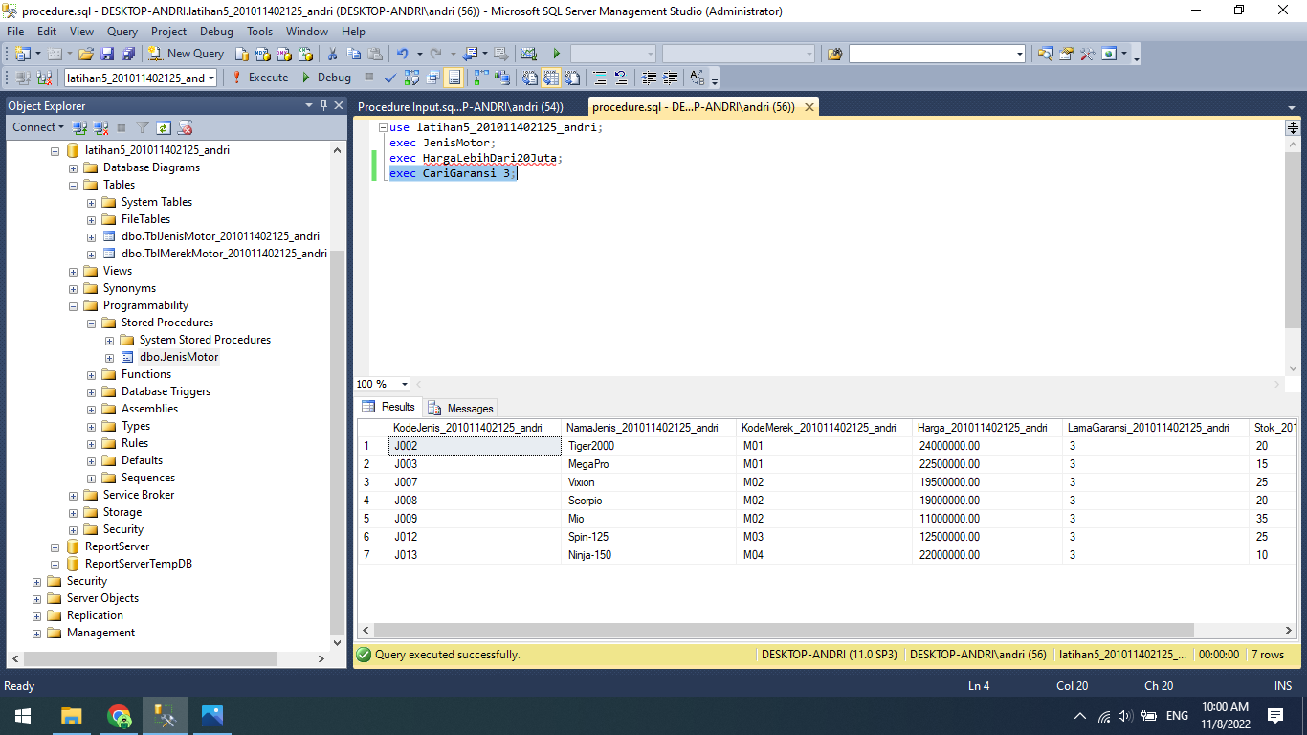

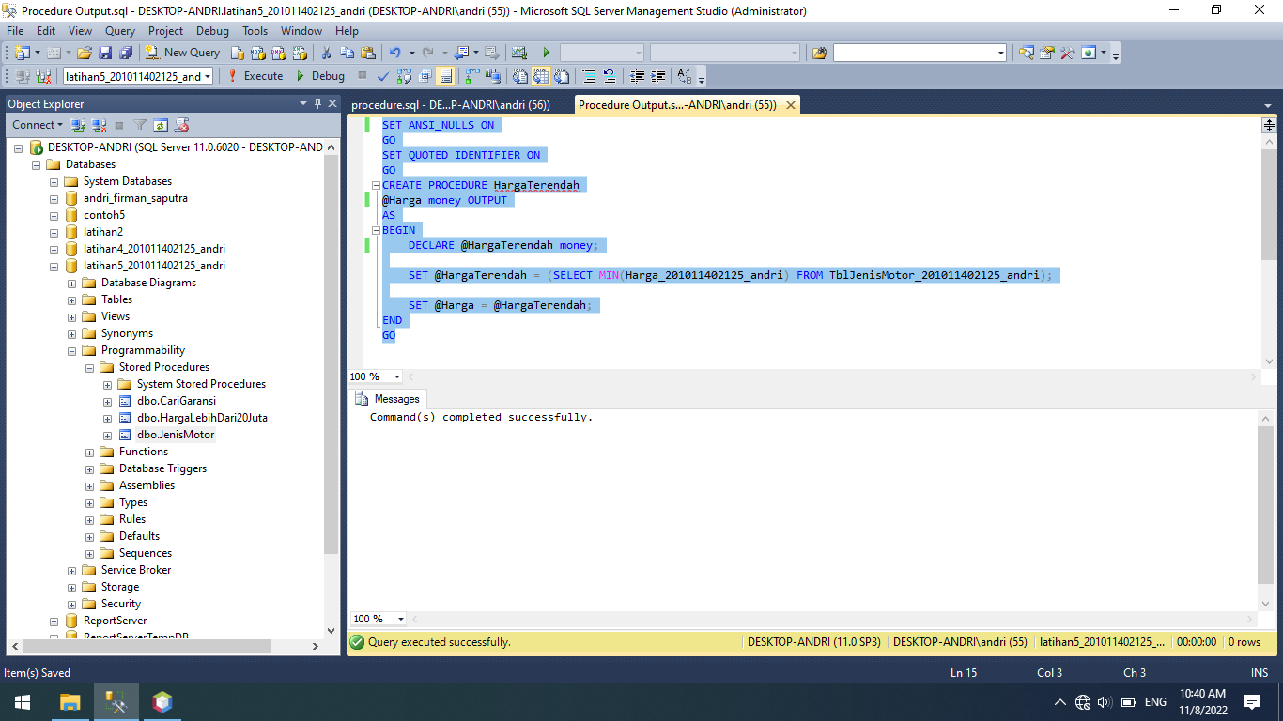

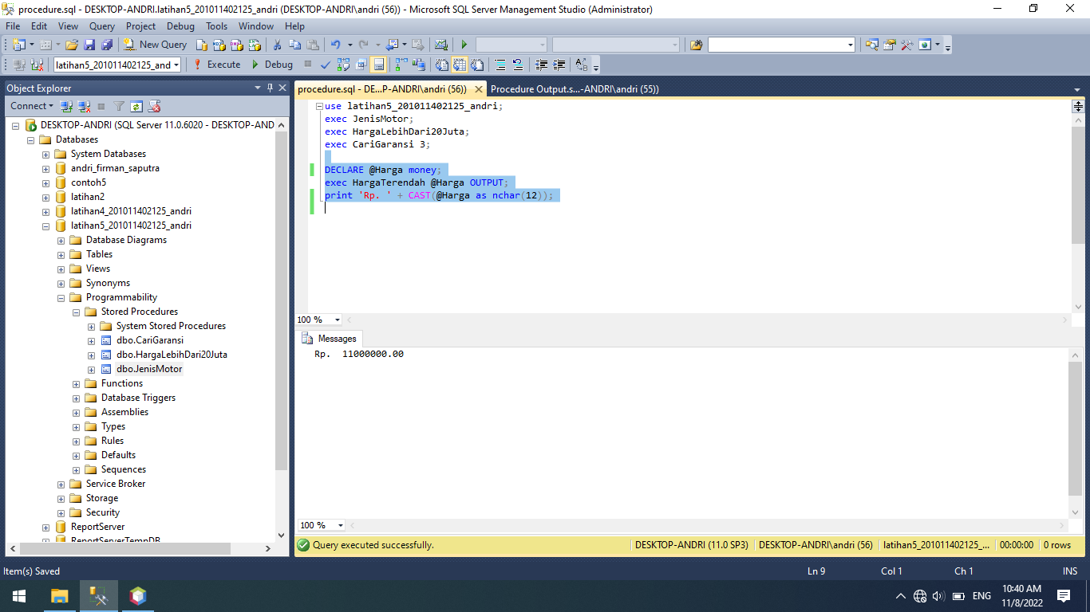

**Source Code:**

SET ANSI_NULLS ON

GO

SET QUOTED_IDENTIFIER ON

GO

CREATE PROCEDURE JenisMotor

AS

BEGIN

SET NOCOUNT ON;

SELECT * FROM TblJenisMotor_201011402125_andri;

END

GO

SET ANSI_NULLS ON

GO

SET QUOTED_IDENTIFIER ON

GO

CREATE PROCEDURE HargaLebihDari20Juta

AS

BEGIN

SET NOCOUNT ON;

DECLARE @harga float;

SET @harga = 22500000;

SELECT * FROM TblJenisMotor_201011402125_andri WHERE Harga_201011402125_andri > @harga;

END

GO

SET ANSI_NULLS ON

GO

SET QUOTED_IDENTIFIER ON

GO

CREATE PROCEDURE CariGaransi

@LamaGaransi char(2)

AS

BEGIN

SET NOCOUNT ON;

SELECT * FROM TblJenisMotor_201011402125_andri

WHERE LamaGaransi_201011402125_andri = @LamaGaransi;

END

GO

SET ANSI_NULLS ON

GO

SET QUOTED_IDENTIFIER ON

GO

CREATE PROCEDURE HargaTerendah

@Harga money OUTPUT

AS

BEGIN

DECLARE @HargaTerendah money;

SET @HargaTerendah = (SELECT MIN(Harga_201011402125_andri) FROM TblJenisMotor_201011402125_andri);

SET @Harga = @HargaTerendah;

END

GO

use latihan5_201011402125_andri;

exec JenisMotor;

exec HargaLebihDari20Juta;

exec CariGaransi 3;

DECLARE @Harga money;

exec HargaTerendah @Harga OUTPUT;

print 'Rp. ' + CAST(@Harga as nchar(12));